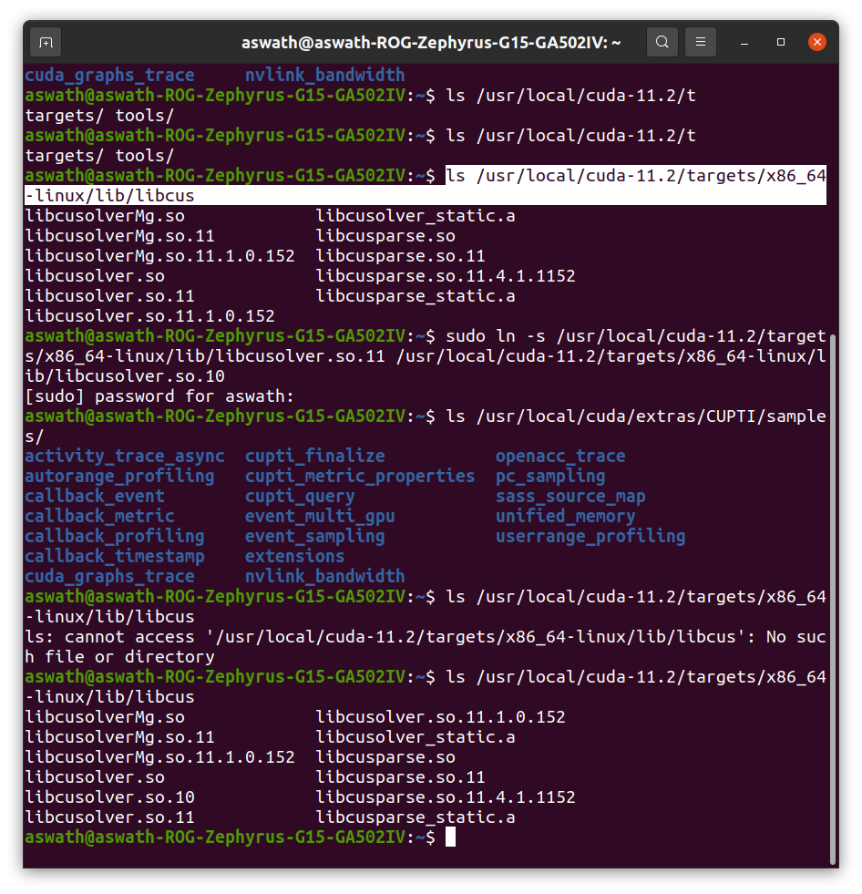

pip install tf-nightly-gpu

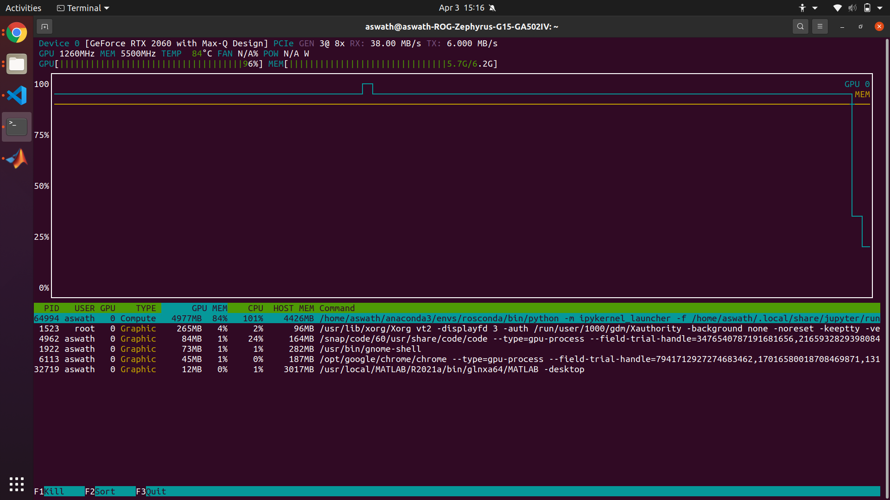

**aswath@aswath-ROG-Zephyrus-G15-GA502IV**:**~/Videos/myvideo**$ ffmpeg -i groundvideo.mp4 -vf fps=5 img-%d.jpg

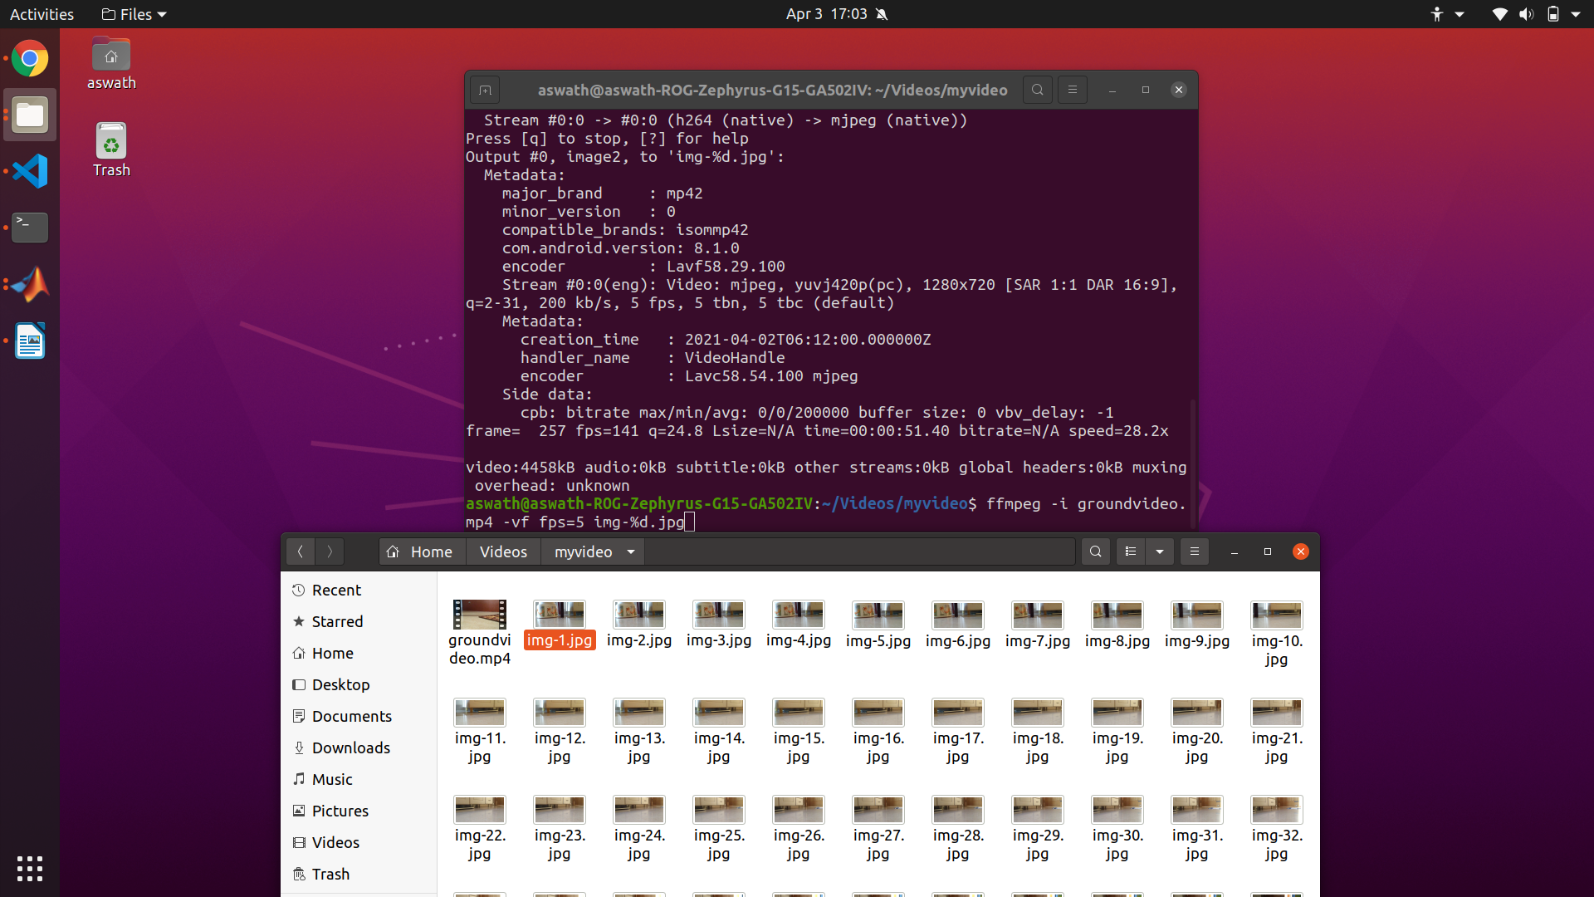

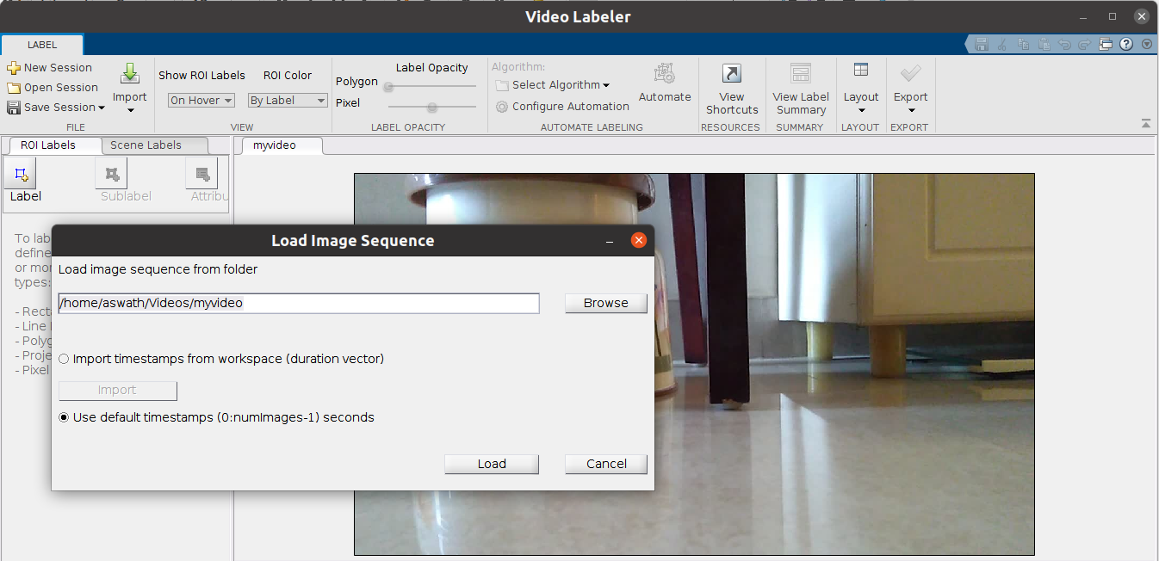

**aswath@aswath-ROG-Zephyrus-G15-GA502IV**:**~/Videos**$ tree myvideo/ -d

**myvideo/**

├── **export**

│   └── **PixelLabelData**

└── **mydata**

├── **annotations**

│   ├── **training**

│   └── **validation**

└── **images**

├── **training**

└── **validation**

9 directories

**aswath@aswath-ROG-Zephyrus-G15-GA502IV**:**~/Videos**$ tree myvideo/ -P *.mp4

**myvideo/**

├── **export**

│   └── **PixelLabelData**

├── **groundvideo.mp4**

└── **mydata**

├── **annotations**

│   ├── **training**

│   └── **validation**

└── **images**

├── **training**

└── **validation**

9 directories, 1 file

Build a fast semantic segmentation network:

https://nanonets.com/blog/semantic-image-segmentation-2020/

https://arxiv.org/pdf/2005.10821v1.pdf

https://arxiv.org/pdf/2101.06085v1.pdf

<https://towardsdatascience.com/enet-a-deep-neural-architecture-for-real-time-semantic-segmentation-2baa59cf97e9> ENet — A Deep Neural Architecture for Real-Time Semantic Segmentation

<https://heartbeat.fritz.ai/the-5-algorithms-for-efficient-deep-learning-inference-on-small-devices-bcc2d18aa806> The 5 Algorithms for Efficient Deep Learning Inference on Small Devices

<https://arxiv.org/abs/1902.04502> Fast-SCNN: Fast Semantic Segmentation Network

<https://openreview.net/pdf?id=S1uHiFyyg> Speeding up Semantic Segmentation for Autonomous Driving

<https://ieeexplore.ieee.org/document/9102769> Lightningnet: Fast and Accurate Semantic Segmentation for Autonomous Driving Based on 3D LIDAR Point Cloud

https://openaccess.thecvf.com/content_ICCVW_2019/papers/CVRSUAD/Zhuang_ShelfNet_for_Fast_Semantic_Segmentation_ICCVW_2019_paper.pdf

https://smartlabai.medium.com/deep-learning-based-semantic-segmentation-in-simulation-and-real-world-for-autonomous-vehicles-e7fe25cef816